WEEK-6

React

1.ReactJS-HOL

CODE:

App.js

import React from 'react';

function App() {

  return (

    <div>

      <h1>Welcome to the first session of React</h1>

    </div>

  );

}

export default App;

OUTPUT:

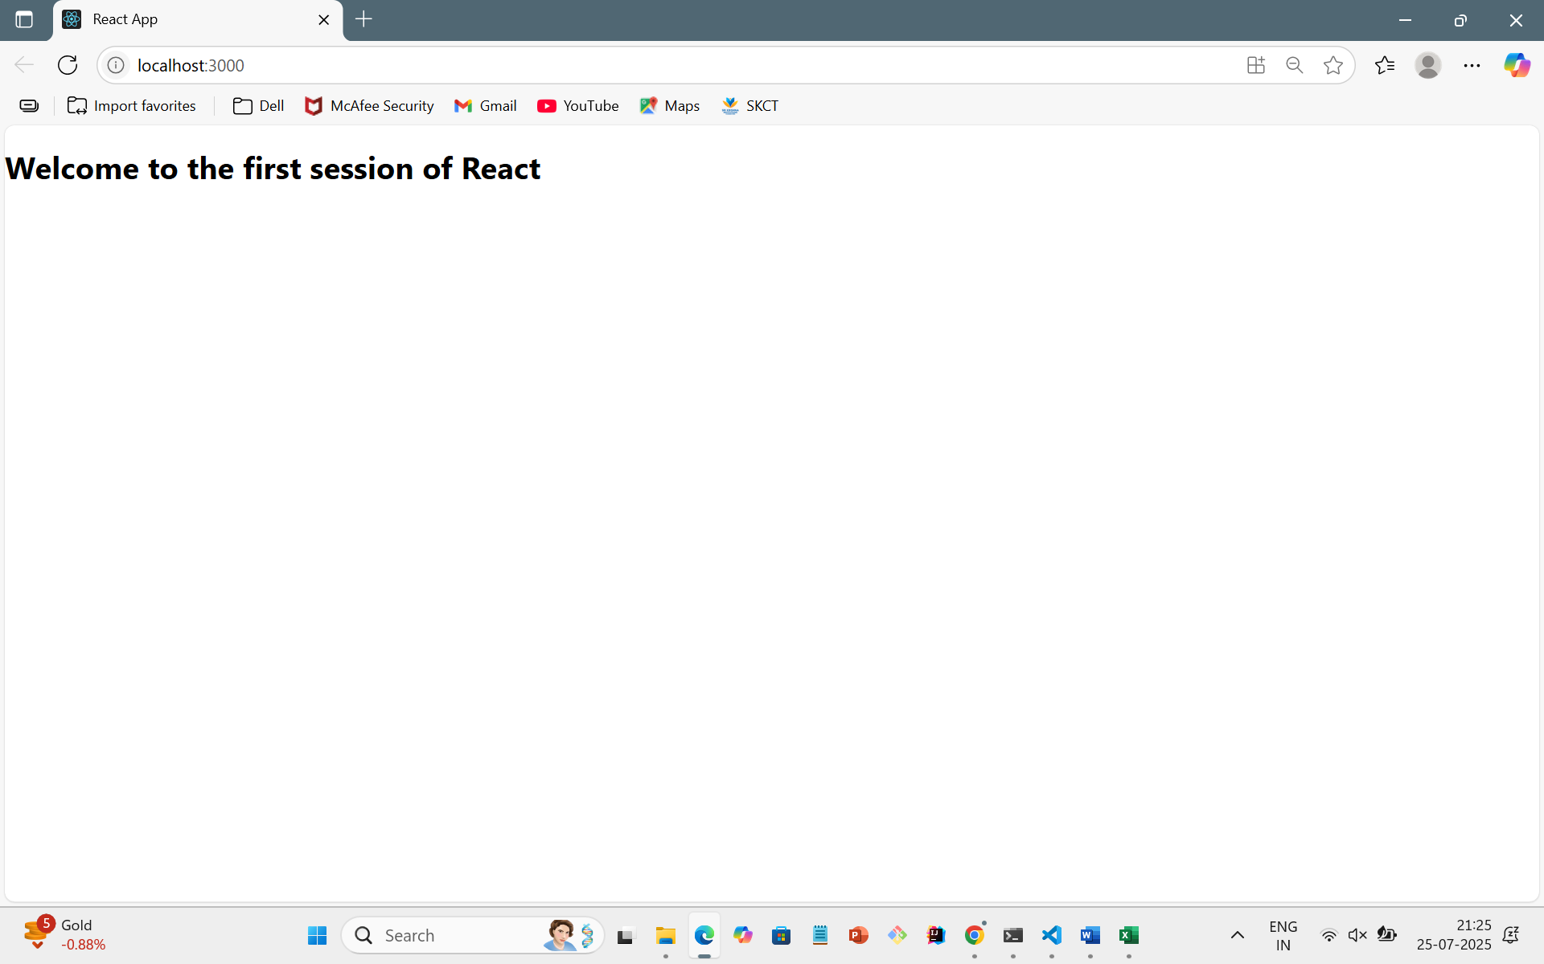

2. ReactJS-HOL

CODE:

Home.js

import React from 'react';

function Home() {

  return (

    <div>

      <h2>Welcome to the Home page of Student Management Portal</h2>

    </div>

  );

}

export default Home;

About.js:

import React from 'react';

function About() {

  return (

    <div>

      <h2>Welcome to the About page of the Student Management Portal</h2>

    </div>

  );

}

export default About;

Contact.js:

import React from 'react';

function Contact() {

  return (

    <div>

      <h2>Welcome to the Contact page of the Student Management Portal</h2>

    </div>

  );

}

export default Contact;

App.js

import React from 'react';

import Home from './Components/Home';

import About from './Components/About';

import Contact from './Components/Contact';

function App() {

  return (

    <div>

      <h1>Student Management Portal</h1>

      <Home />

      <About />

      <Contact />

    </div>

  );

}

export default App;

OUTPUT:

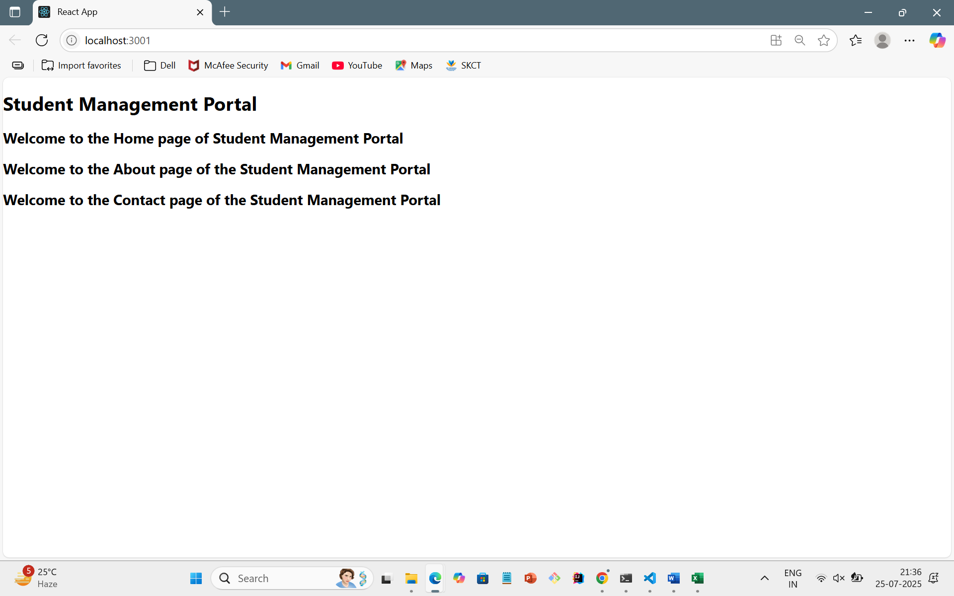

3. ReactJS-HOL

CODE:

CalculateScore.js

import '../Stylesheets/mystyle.css';

const percentToDecimal = (decimal) => {

  return (decimal \* 100).toFixed(2) + '%';

};

const calcScore = (total, goal) => {

  return percentToDecimal(total / goal);

};

export const CalculateScore = ({ Name, School, total, goal }) => (

  <div className="formatstyle">

    <h1><font color="Brown">Student Details:</font></h1>

    <div className="Name">

      <b><span>Name: </span></b>

      <span>{Name}</span>

    </div>

    <div className="School">

      <b><span>School: </span></b>

      <span>{School}</span>

    </div>

    <div className="Total">

      <b><span>Total: </span></b>

      <span>{total}</span> Marks

    </div>

    <div className="Score">

      <b>Score: </b>

      {calcScore(total, goal)}

    </div>

  </div>

);

Mystyle.css

.Name {

  font-weight: 300;

  color: blue;

}

.School {

  color: crimson;

}

.Total {

  color: darkmagenta;

}

.formatstyle {

  text-align: center;

  font-size: large;

}

.Score {

  color: forestgreen;

}

App.js

import { CalculateScore } from './Components/CalculateScore';

function App() {

  return (

    <div>

      <CalculateScore

        Name="Steeve"

        School="DNV Public School"

        total={284}

        goal={300}

      />

    </div>

  );

}

export default App;

OUTPUT:

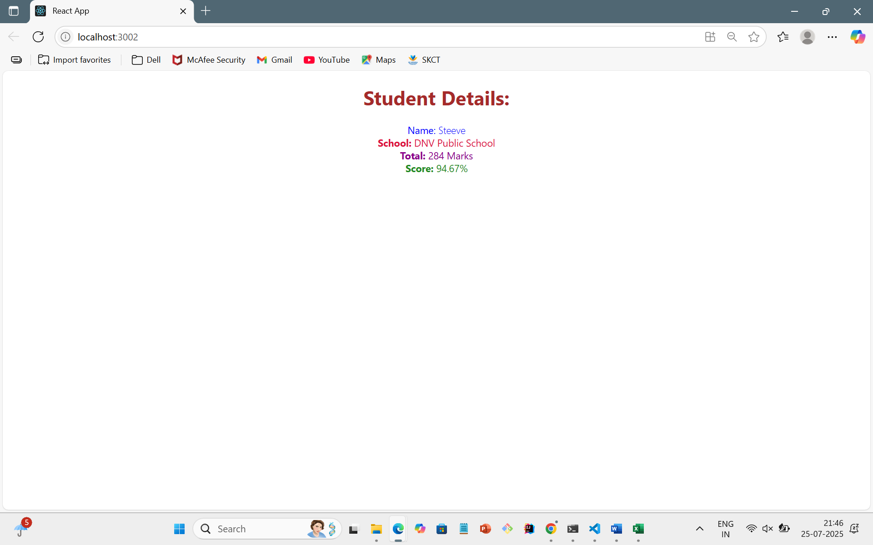

4. ReactJS-HOL

CODE:

Post.js

class Post {

  constructor(id, title, body) {

    this.id = id;

    this.title = title;

    this.body = body;

  }

}

export default Post;

Posts.js

import React, { Component } from 'react';

import Post from './Post';

class Posts extends Component {

  constructor(props) {

    super(props);

    this.state = {

      posts: []

    };

  }

  loadPosts = () => {

    fetch('https://jsonplaceholder.typicode.com/posts')

      .then((res) => res.json())

      .then((data) => {

        const postObjects = data.map((item) => new Post(item.id, item.title, item.body));

        this.setState({ posts: postObjects });

      })

      .catch((error) => {

        console.error('Error fetching posts:', error);

        throw error;

      });

  };

  componentDidMount() {

    this.loadPosts();

  }

  componentDidCatch(error, info) {

    alert('An error occurred: ' + error.message);

  }

  render() {

    return (

      <div>

        <h1>Blog Posts</h1>

        {this.state.posts.map((post) => (

          <div key={post.id}>

            <h3>{post.title}</h3>

            <p>{post.body}</p>

            <hr />

          </div>

        ))}

      </div>

    );

  }

}

export default Posts;

App.js

import React from 'react';

import Posts from './Posts';

function App() {

  return (

    <div className="App">

      <Posts />

    </div>

  );

}

export default App;

OUTPUT:

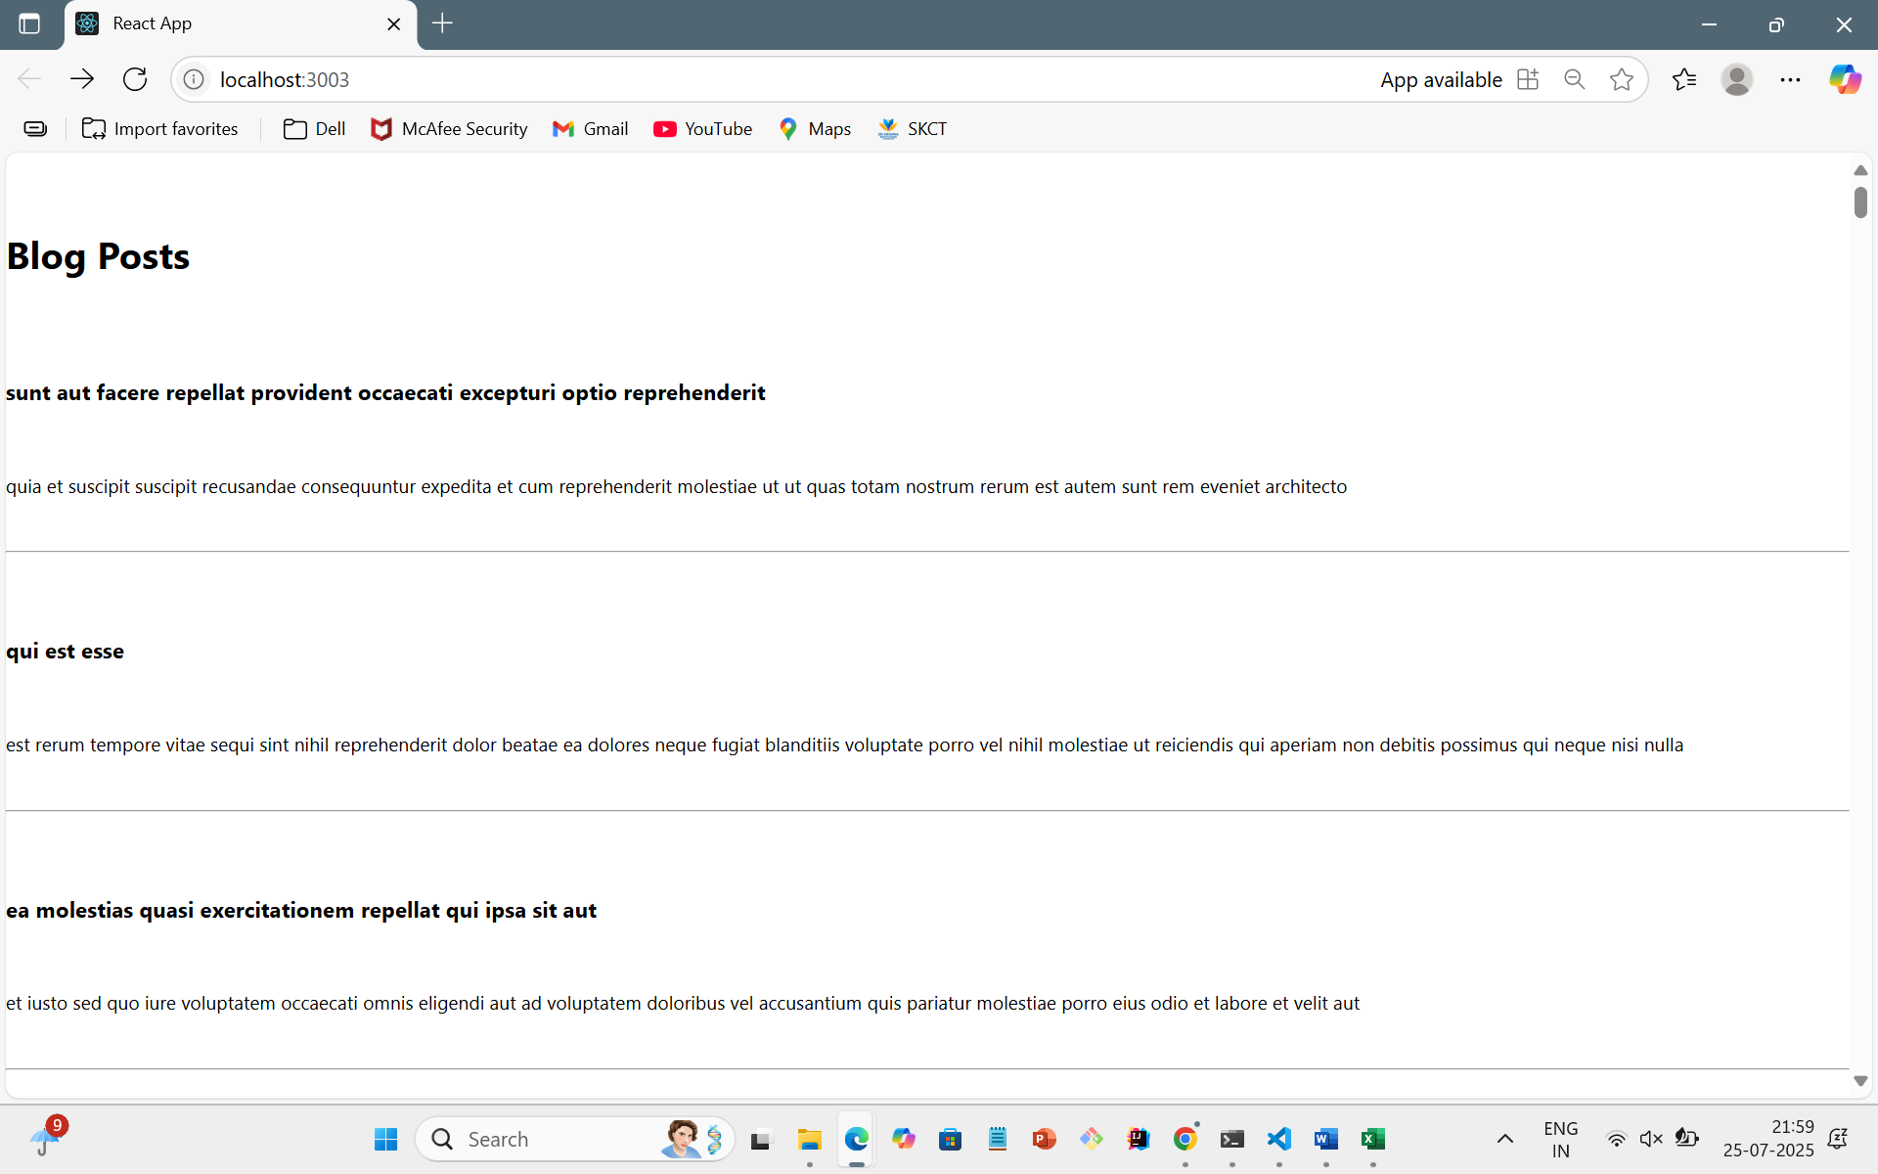

5. ReactJS-HOL

CODE:

CohortDetails.js

import React from 'react';

import styles from './CohortDetails.module.css';

const CohortDetails = ({ cohort }) => {

  const headingStyle = {

    color: cohort.status.toLowerCase() === 'ongoing' ? 'green' : 'blue',

  };

  return (

    <div className={styles.box}>

      <h3 style={headingStyle}>{cohort.name}</h3>

      <dl>

        <dt>Started On</dt>

        <dd>{cohort.startDate}</dd>

        <dt>Current Status</dt>

        <dd>{cohort.status}</dd>

        <dt>Coach</dt>

        <dd>{cohort.coach}</dd>

        <dt>Trainer</dt>

        <dd>{cohort.trainer}</dd>

      </dl>

    </div>

  );

};

export default CohortDetails;

CohortDetails.module.css

.box {

  width: 300px;

  display: inline-block;

  margin: 10px;

  padding: 10px 20px;

  border: 1px solid black;

  border-radius: 10px;

}

dt {

  font-weight: 500;

}

App.js

import React from 'react';

import CohortDetails from './CohortDetails';

function App() {

  const cohorts = [

    {

      name: 'INTADMDF10-.NET FSD',

      startDate: '22-Feb-2022',

      status: 'Scheduled',

      coach: 'Aathma',

      trainer: 'Jojo Jose',

    },

    {

      name: 'ADM21JF014-Java FSD',

      startDate: '10-Sep-2021',

      status: 'Ongoing',

      coach: 'Apoorv',

      trainer: 'Elisa Smith',

    },

    {

      name: 'CDBJF21025-Java FSD',

      startDate: '24-Dec-2021',

      status: 'Ongoing',

      coach: 'Aathma',

      trainer: 'John Doe',

    },

  ];

  return (

    <div>

      <h2>Cohorts Details</h2>

      {cohorts.map((cohort, index) => (

        <CohortDetails key={index} cohort={cohort} />

      ))}

    </div>

  );

}

export default App;

OUTPUT:

